PROJECT DEMONSTRATION
1. Demonstration Overview
The demonstration explains the complete workflow of importing employee data into ServiceNow and displaying the results through reports and dashboards.
2. Demonstration Steps
- Show the employee spreadsheet.
- Show the Employee Test target table.
- Explain the Import Set and Transform Map.
- Demonstrate Coalesce and duplicate prevention.
- Show the three employee reports.
- Show the Employee Analytics Dashboard.
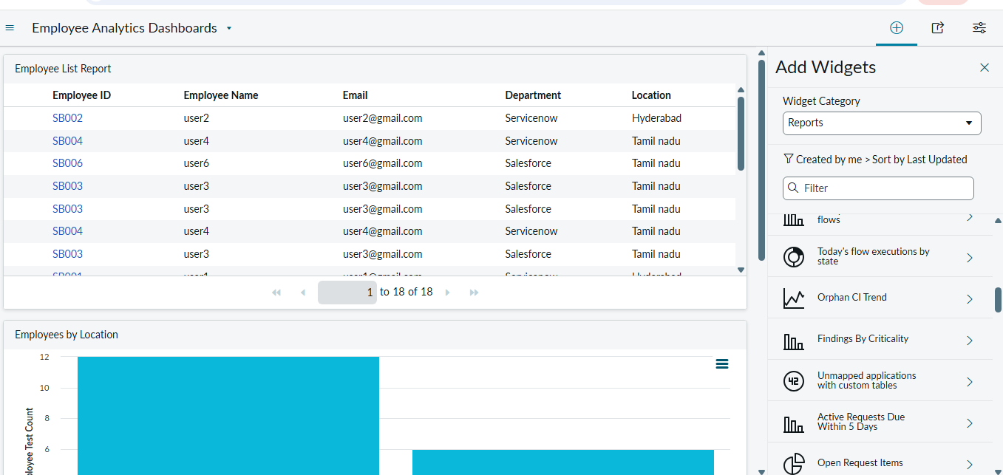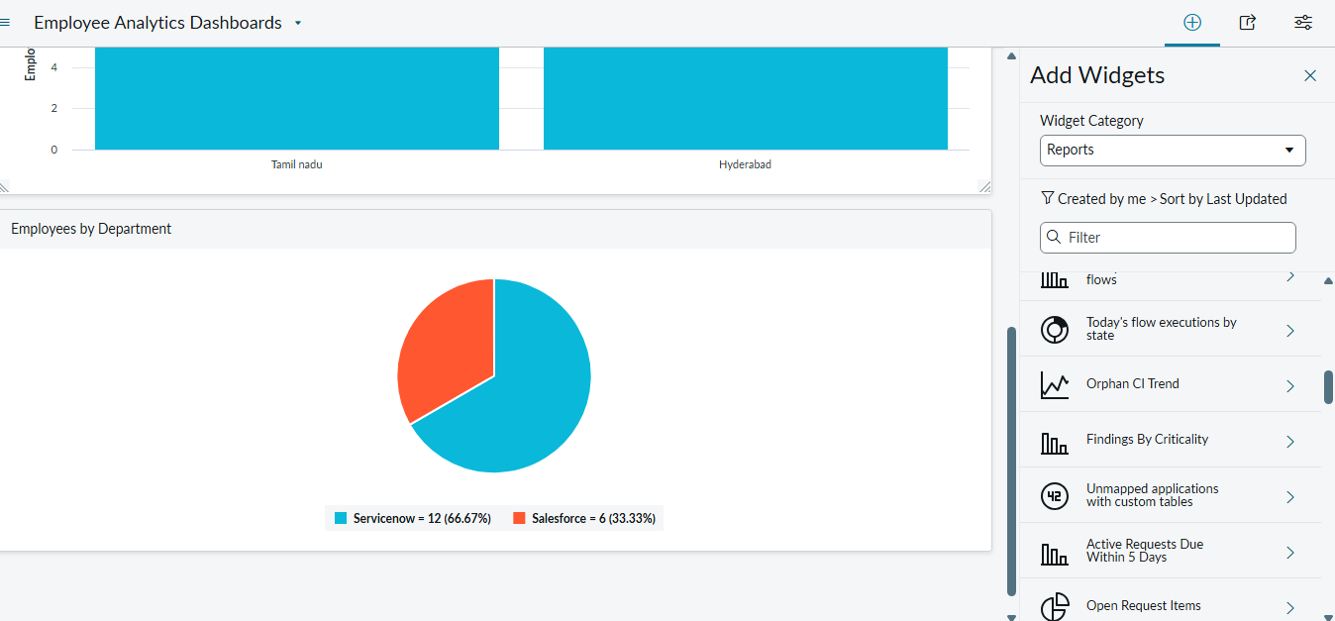
3.Demonstration Link
https://1drv.ms/f/c/338749EF309DA138/IgDP_rqXFtB-Q4qK-k7RAERWAcBq_3fdUrnDm6Dm8e51sr0

